CCH COMMUNITY YARD SALE
AND
PLANT SALE

MAY 13, 9AM TO 1PM

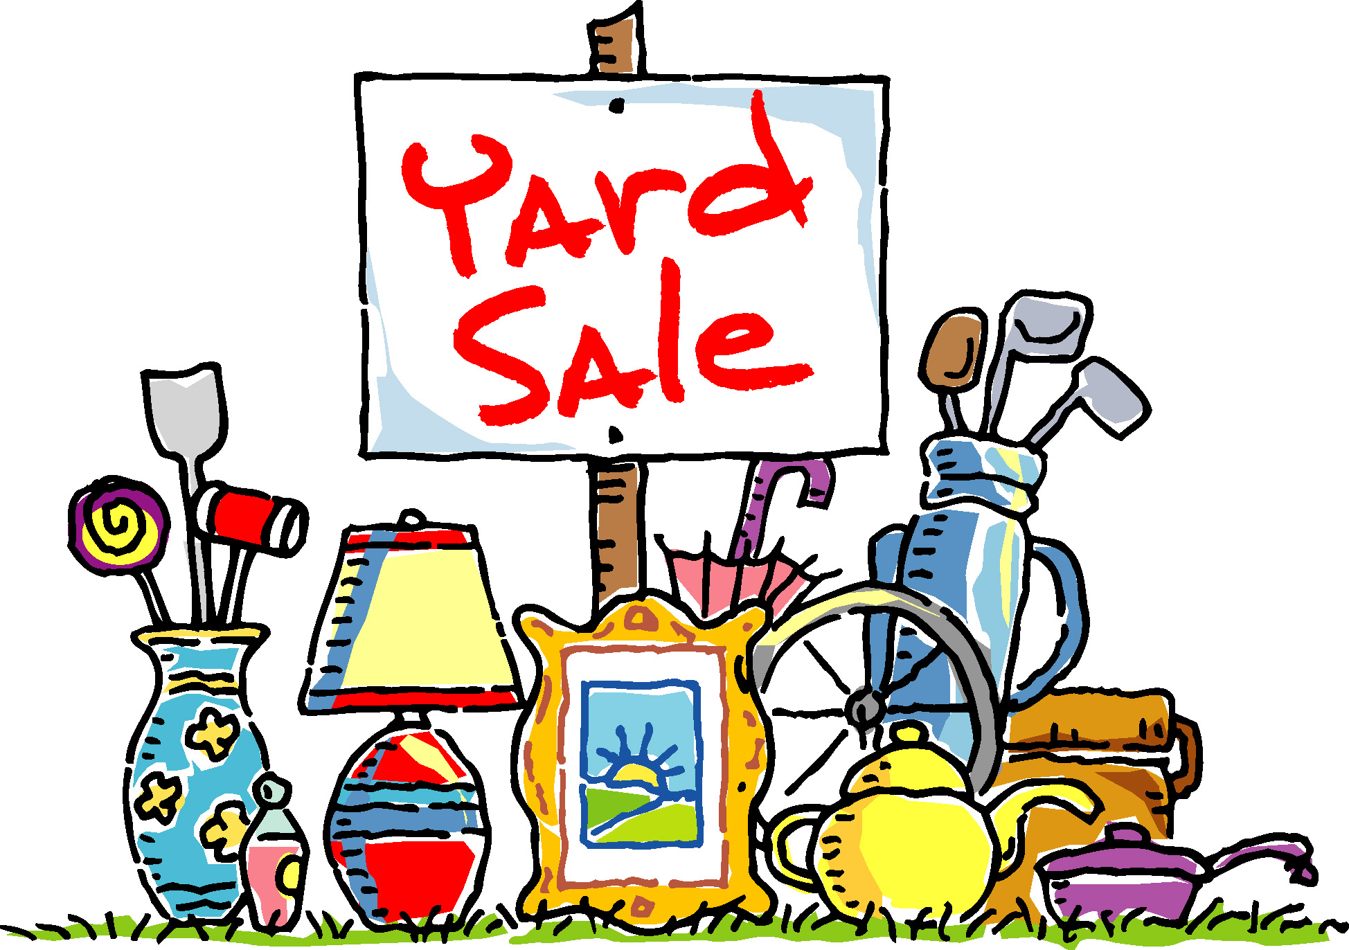

YOUR JUNK IS SOMEONE ELSE’S TREASURE!!

SET UP YOUR SALE EITHER IN YOUR YARD – OR AT THE COMMON AREA (ON SPRING LAKE TERRACE)

FLAG YOUR SALE BY PUTTING UP BALLOONS

For your convenience, an AmVets truck will collect any unwanted items but you must e-mail Leslie at lesdan001@verizon.net by May 8th with your name/address/phone number if you would like your items picked up.

** COUNTRY CLUB HILLS GARDEN CLUB WILL BE SELLING PLANTS
AT THE COMMON AREA **

